**Business Requirements Document (BRD)**

**1. Overview**

The purpose of this dashboard is to support the Loan Servicing team with high level insights into monthly loan performance. It will help stakeholders monitor portfolio health, assess risk exposure, track delinquency, and make data informed operational decisions.

**2. Stakeholders and Goals**

**Loan Servicing Analysts**

Goal: Monitor loan volume and servicing workload

They need to understand the overall size and activity of the loan portfolio to manage daily operations and allocate resources. Metrics like Total Active Loans and Portfolio Size help them monitor trends in loan activity and portfolio growth, enabling them to identify service demand and ensure efficient workload distribution.

**Collections Team**

Goal: Identify and prioritize delinquent accounts

They focus on recovering overdue payments efficiently. Key metrics such as Aging Buckets and Top Delinquent Accounts allow them to segment past-due loans by severity (e.g., 31–60, 61–90, 91+ days overdue) and prioritize accounts with the highest outstanding balances, improving recovery outcomes.

**Risk Management Team**

Goal: Track risk exposure and delinquency trends

They evaluate the credit health of the loan portfolio and identify systemic risks. Metrics like Delinquency Rate and Average Days Past Due provide insights into delinquency trends and allow for early identification of high-risk patterns, which supports regulatory reporting and internal risk mitigation strategies.

**Finance Team**

Goal: Evaluate financial losses

They assess the financial impact of non-performing loans. Metrics such as Charged-Off Loan Count and Charged-Off Loan Balance provide clarity on loan losses, which is critical for financial reporting, provisioning, and long-term planning.

**3. Key Metrics and KPIs**

|  |  |  |  |  |
| --- | --- | --- | --- | --- |
| **Stakeholder** | **Goal** | **Metric** | **Calculation** | **Source Table** |
| Loan Servicing Analysts | Monitor loan volume and servicing workload | Total Active Loans | Count of loans where Status = 'Active' | LoanAccounts |
|  |  | Portfolio Size ($) | Sum of Outstanding Balance where Status = 'Active' | LoanAccounts |
| Collections team | Identify and prioritize delinquent accounts | Aging Buckets | Group loans by DaysPastDue (Current date – Payment date): 31–60, 61–90, 91+ | PaymentEvents |
|  |  | Top Delinquent Accounts | Filter DaysPastDue > 60, sort by Outstanding Balance DESC | LoanAccounts, PaymentEvents |
| Risk Management Team | Track risk exposure and delinquency trends | Delinquency Rate (%) | Count of loans where DaysPastDue > 60 ÷ Total Active Loans | PaymentEvents |
|  |  | Avg. Days Past Due | Average DaysPastDue where Status = 'Delinquent' | PaymentEvents |
| Finance Team | Evaluate financial losses | Charged-Off Loan Count | Count of loans where Status = 'Charged-Off' | LoanAccounts |
|  |  | Charged-Off Loan Balance ($) | Sum of Outstanding Balance where Status = 'Charged-Off' | LoanAccounts |

**4. Proposed Mockup**

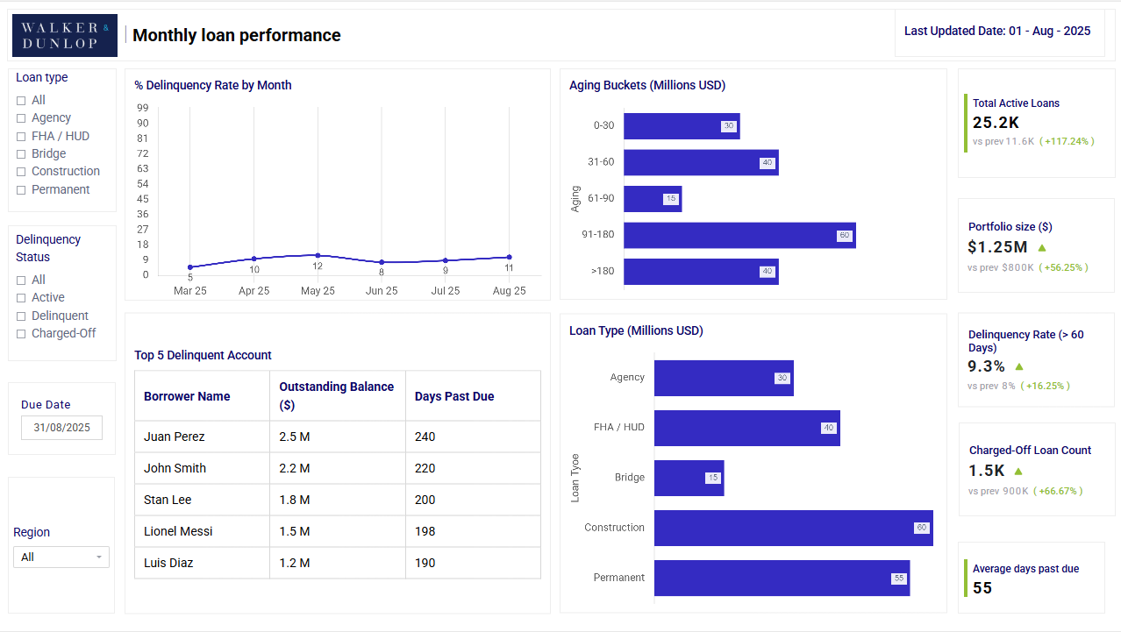

**5. Assumptions and Gaps**

* Status field in LoanAccounts must be standardized (Active, Delinquent , Charged-Off)
* Monthly metrics reflect loan data as of the last calendar day of each month.
* Status is “Delinquent” when DaysPastDue is more than 60 days and less than 180 days
* A loan is considered **“Charged-Off”** when DaysPastDue > 180